Title (Arial 20, bold)
Subtitle (Arial 14, regular)

Title [in mother tongue] (Arial 20, bold)
Subtitle (Arial 14, regular)

Surname, Name¹; Surname, Name² (Arial 12, bold)
1. Institution, Department, Center, City, Country, e-mail, orcid (Arial 12, regular)
2. Institution, Department, Center, City, Country, e-mail, orcid (Arial 12, regular)

Abstract (Arial 12, bold)
(Arial 10, regular) Bacon ipsum dolor sit amet pancetta strip steak kielbasa tail frankfurter kevin. Drumstick jowl andouille biltong pork boudin. Ribeye pig short loin, jowl pastrami shankle doner prosciutto kevin pork loin tenderloin boudin tongue. Tri-tip meatloaf shoulder drumstick pig capicola. Turducken bacon kevin, shank tail beef ribs rump ham jowl short loin t-bone venison salami pancetta pastrami. Capicola pork chop pig bresaola pork loin sausage beef ribs ham hock hamburger shank. Sausage cow t-bone beef ribs swine. Tenderloin leberkas pig, pork loin meatball kielbasa fatback. Chuck kielbasa meatloaf boudin, tenderloin shankle pig hamburger sausage strip steak ribeye rump andouille. Shoulder sirloin capicola, biltong brisket fatback short loin strip steak venison drumstick tongue shankle pig. Boudin shankle biltong strip steak beef ribs pastrami flank. Tongue ribeye shoulder venison. Biltong porchetta pig short ribs salami, doner t-bone beef tenderloin ham hock tail. Kevin capicola t-bone sirloin tri-tip, porchetta pork boudin tenderloin chuck bacon. Shankle t-bone kielbasa, jowl landjaeger porchetta shoulder leberkas pork chop beef meatball bacon corned beef. Tenderloin drumstick pork chop venison ball tip shoulder ribeye pastrami pancetta doner filet mignon sirloin rump. Jowl bacon ball tip sausage, ham meatloaf drumstick beef ribs chicken cow venison brisket turkey pork belly flank. Pork chop tail.
Key words: Maximum of 5, separated by commas. (Arial 12, regular)

Abstract [in mother tongue] (Arial 12, bold)
(Arial 10, regular) Bacon ipsum dolor sit amet pancetta strip steak kielbasa tail frankfurter kevin. Drumstick jowl andouille biltong pork boudin. Ribeye pig short loin, jowl pastrami shankle doner prosciutto kevin pork loin tenderloin boudin tongue. Tri-tip meatloaf shoulder drumstick pig capicola. Turducken bacon kevin, shank tail beef ribs rump ham jowl short loin t-bone venison salami pancetta pastrami. Capicola pork chop pig bresaola pork loin sausage beef ribs ham hock hamburger shank. Sausage cow t-bone beef ribs swine. Tenderloin leberkas pig, pork loin meatball kielbasa fatback. Chuck kielbasa meatloaf boudin, tenderloin shankle pig hamburger sausage strip steak ribeye rump andouille. Shoulder sirloin capicola, biltong brisket fatback short loin strip steak venison drumstick tongue shankle pig. Boudin shankle biltong strip steak beef ribs pastrami flank. Tongue ribeye shoulder venison. Biltong porchetta pig short ribs salami, doner t-bone beef tenderloin ham hock tail. Kevin capicola t-bone sirloin tri-tip, porchetta pork boudin tenderloin chuck bacon. Shankle t-bone kielbasa, jowl landjaeger porchetta shoulder leberkas pork chop beef meatball bacon corned beef. Tenderloin drumstick pork chop venison ball tip shoulder ribeye pastrami pancetta doner filet mignon sirloin rump. Jowl bacon ball tip sausage, ham meatloaf drumstick beef ribs chicken cow venison brisket turkey pork belly flank. Pork chop tail.
Key words: Maximum of 5, separated by commas. [in mother tongue] (Arial 12, regular)

Manuscripts
The articles should include a consistent focus, clear definition of the research framework, and give a deep understanding of the subject or topic described, including findings, reflections, and conclusions.

Style and Conventions
Manuscripts should be submitted online in Microsoft Word Format (.docx). In case of proposals using symbols (e.g., phonetic transcriptions), you are kindly requested to add a PDF version.
The first page will act as the cover. In this page, the authors must present the title, abstract (max. 500 words) and keywords (3-5) in both mother tongue language and English. All this information may not exceed the length of a single page of this format.
The article will be written in Arial 12, with simple line spacing and indented. Bold or italic can be used; although it is preferable to use italics instead of bold to emphasize. Capitals words will be avoided in both the titles and the text.
The use of hyphens will be preferred to the use of parentheses. Dates should be in the form of ‘day month year’, e.g., 18 March 2020. When using abbreviations or acronyms, spell them out in full on their first use (except for universally known ones such as UK, USA, UN, etc.). Do not use full points within abbreviations or acronyms.

Language
Only articles in English will be accepted, an abstract both in English and in the mother tongue language of the author should be included.

Length
The length of the articles will be within 3,500 and 8,000 words, including title, abstract (both in English and in the mother tongue language), keywords, and references.

Margins
The margins to be used are: 3 cm upper, 3 cm lower, 3 cm left and 3 cm right; and complete justification.

Paragraph titles
Divide your article into clearly defined sections.
Paragraph titles will be written in Arial 12, bold, with capital letters, and they should be aligned to the left, without indentation and with decimal numeration.

Titles Level 2
Paragraph titles (level 2) will be written in Arial 12, italic, and they should be aligned to the left, without indentation and without decimal numeration.

Notes
They will be included as footnotes. Written in Arial 8, single line spacing, without indentation and numbered starting at 1. In the body of the text, superscripts^{[1]} will be used to reference the notes.

Graphics, tables and images
They must be included in the text (no more than 10) with a maximum width of 15 cm. In case of not completing the paragraph width, center it.
Each graphic, table or image must be numbered below as Fig. X (Arial, size 9) and referenced within the text as (Fig. 1). All figures should have brief captions.
Figures should be supplied digitally as separate files. Figures can be either .jpg or .tiff saved at 300 dpi and with a length of 150 mm on the long axis Line drawings should be .eps files at 1200 dpi and with a length of 150 mm on the long axis.
Authors are responsible for obtaining permission from copyright holders for reproducing any figures used in their articles.
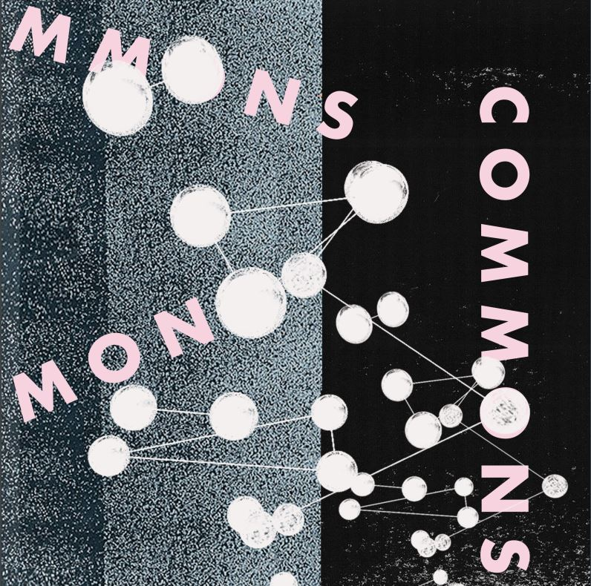
Fig. 1 – Front page for the issue 1 ‘Commons’ of the UOU journal.

Enumerations
Authors should use only hyphens, which will be of different sizes if there are several levels.
– First level of enumeration.
- Second level of enumeration.

Bibliography
It will be included at the end of the article, written in Arial, size 10, with simple line spacing and without indentation. The references will appear in alphabetical order at the end of the article. For all references formats will be used the international standard ISO 690.

Bibliographical References
All the references mentioned throughout the text must be added to the section ‘Works Cited’.
Specific pages should be used for all the quotation.
Surname of the first author should be written in small caps.
Leave page number in full for both in text-citations and for pages in the works cited (e.g., Nilsson 2000, 115-126). Do not use abbreviated forms, as in 115-26.
Do not use Latin reference tags (op. cit., ibidem, etc.).
Use initialisms to indicate that some information is not available:
– (n.p.) for ‘no publisher’, ‘no place of publication’ or ‘no page’.
– (n.d.) for ‘no date’.
The names of publishers or publishing company names will be as much abbreviated as possible: avoid using ‘Co.’ or ‘Inc.’ and descriptive words (Publishing, etc.). The words ‘university’ and ‘press’ will be abbreviated in any of the corresponding forms: U of Chicago P or Oxford UP.
The full names of authors will be provided.
If any of the author-date cases of citation are not listed here, please check the guide of help for the norm ISO 690 (PDF) by the Library of Alicante University.

Book with one author.
SURNAME(S), Name. Title of the book (in italics). Edition (if it is not the first edition). City: Publisher, Publication date. ISBN number (if available)
ORTEA VARELA, Enrique. Técnicas de fabricación mecánica. Langreo: Ediciones EO, 2014. ISBN 978-84-943-0311-1
In-text citation (Ortea Varela, 2104)

Book with up to three authors.
SURNAME(S), Name, Name SURNAME, Name SURNAME. Title of the book (in italics). Edition (if it is not the first edition). City: Publisher, Publication date. ISBN number (if available)
MERIAM, James L., L. G. KRAIGE. Mecánica para ingenieros: Dinámica. 3rd edition. Barcelona: Reverté, 2014. ISBN 978-84-291-4409-3
In-text citation (Meriam, Kraige, 2014)

Book with more than three authors.
SURNAME(S), Name and others. Title of the book (in italics). Edition (if it is not the first edition). City: Publisher, Publication date. ISBN number (if available)
BEER, Ferdinand P. and others. Mecánica vectorial para ingenieros: Estática. 10th edition. Mexico: McGraw Hill, 2013. ISBN 978-607-15-0925-3
In-text citation (Beer and others, 2013)

Book chapter
SURNAME(S), Name. Title of the chapter. In: SURNAME(S), Name. Title (in italics). Edition (if it is not the first edition). City: Publisher, Date of publication, inclusive page numbers. Identifier (ISBN number if available)
CORNEJO VEGA, F.J. Estampación. In: ARENILLAS TORREJÓN, J.A. (coord.). Manual de documentación del Patrimonio Mueble. Sevilla: Junta de Andalucía, Consejería de Economía, Innovación, Ciencia y Empleo, 2014, pp. 162-179
In-text citation (Cornejo Vega, 2014)

Journal article
SURNAME(S), Name. Title of the article. In: Title of the journal (in italics). Edition. City: Publisher, Date of publication, Vol., num., inclusive page numbers. Standardised identifier (ISSN, DOI etc., if available)
LÓPEZ JIMÉNEZ, A. El arte en la calle. In: Reis: Revista Española de Investigaciones Sociológicas. 1998, issue 84, pp. 173-194. ISSN 0210-5233
In-text citation (López Jiménez, 1998)
COSTA, C. Lina Bo Bardi y el suburbio. In: Ecología. ARQ. 2019, 103, pp. 90-103. https://doi.org/10.4067/S0717-69962019000300090

